# Annex 3

**CLASS WORKSHOP – PASCAL’S PRINCIPLE**

Based on the information reviewed and discussed, make the following cases about Pascal's Law.

1. Who was Pascal? What were your main contributions to science?

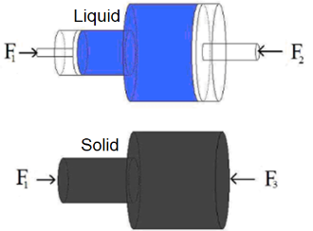2. The same force F1 is exerted on the two objects in the figure by the left side. F2 and F3 are the forces needed to keep each system in equilibrium. Which of these two forces is greater?

a) Largest F2

b) Largest F3

c) F2 y F3 are equal

Justify your answer.

3. The scheme of the figure represents two communicating vessels containing a liquid and hermetically closed with two pistons of mass M1 and M2=M1/3, in the equilibrium position h=3cm. We place on the plunger on the right a mass of M=2M1, then in equilibrium the two pistons are at the same height. Determine the difference in heights at equilibrium when the same mass is placed on the piston on the left.

4. A hypodermic syringe has a plunger with a cross-sectional area of 2,5 cm2 and a needle of 5x10-3cm2. a) If a force of 1N is applied to the piston, what gauge pressure will there be in the syringe chamber? b) If there is a small obstruction at the tip of the needle, what force will the fluid exert on it? c) If the blood pressure in a vein is 50 mmHg, what force must be applied to the plunger to inject fluid into the vein?

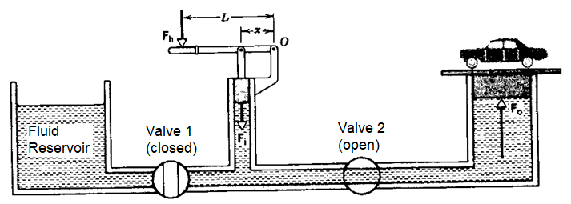5. The figure shows a schematic view of a hydraulic jack used to lift a car. Hydraulic fluid is oil (density=812 kg/m3). A hand pump is used, in which a force of magnitude Fi is applied to the smaller plunger (2,2 cm of diameter) when the hand applies a force of magnitude Fh to the end of the pump handle. The combined mass of the car to be lifted and the lifting platform is M= 1980 kg, and the large plunger has a diameter of 16,4 cm. The length L of the pump handle is 36 cm, and the distance x from the pivot to the plunger is 9,4 cm. a) What is the applied force Fh needed to lift the car? b) For each stroke down the pump, in which the hand moves a vertical distance of 28 cm, how high does the car rise?